SESSION 10: RDBMS (CONTD.)

Assignment 1

**5. Problem Statement**

1. What are the names of all the countries in the databases which start with the letter "B" (sorted by their names)?

Solutions:

USE sakila to change database

Use query: Select distinct country from sakila.country where country like 'B%' order by country;

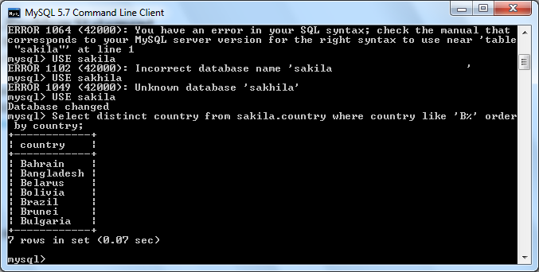

In result you get 7 countries name which start with B and are shorted on base of alphabet.

2. Return the first names (sorted) of all the actors with the last name "berry".

Solution:

USE query

SELECT*FROM sakila.actor WHERE last_name=’Berry’ ORDER BY first_name;

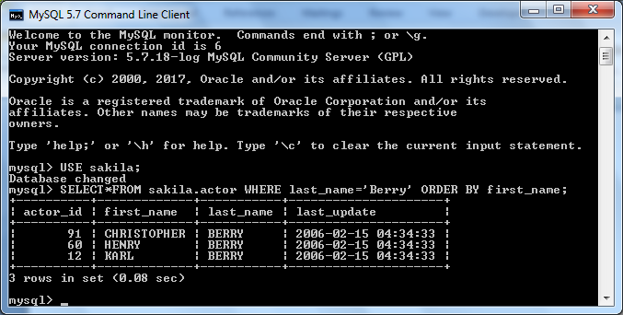

In result you will get three rows where last name of actor is Berry and are shorted by their first name.

3. Find all the films whose length is more than 184 (inclusive). Order the results by the length (and for films with the same length order them by their name). Return their title and the length.

Solution:

Write query

Select Title, Length from Film where Length >= 184 Order by Length;

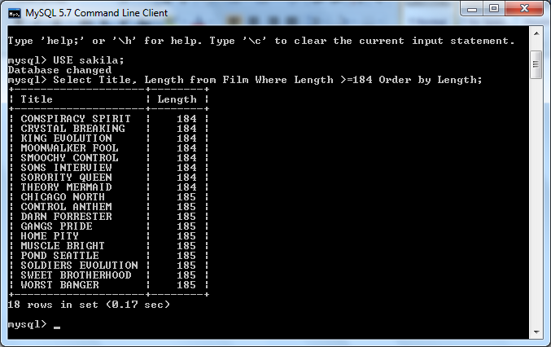

In result you will get 18 tows where firm length has equal or more than 184 mins.